**5. ReactJS-HOL**

1.Create a new React project

|  |
| --- |
| npx create-react-app cohort-dashboard |

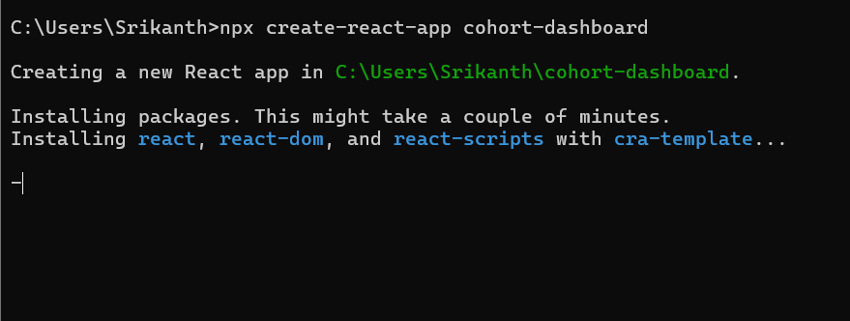

2. Start the development server

|  |
| --- |
| npm start |

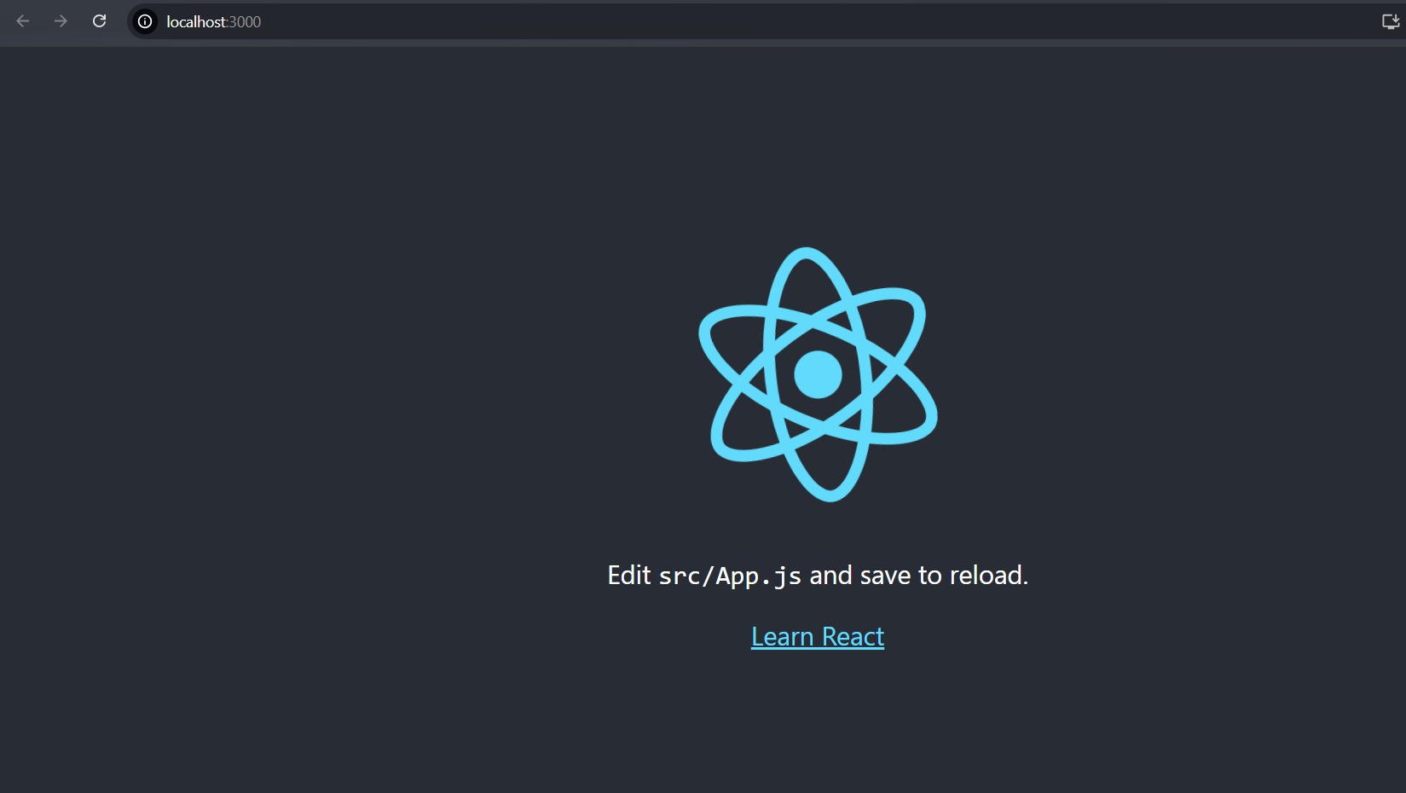

3. Create the CSS Module

|  |
| --- |
| CohortDetails.module.css  .box {    width: 300px;    display: inline-block;    margin: 10px;    padding: 10px 20px;    border: 1px solid black;    border-radius: 10px;  }  dt {    font-weight: 500;  } |

4. Create the CohortDetails component

|  |
| --- |
| CohortDetails.jsx  import React from 'react';  import styles from './CohortDetails.module.css';  const cohorts = [    { id: 'INTADMDF10', title: '.NET FSD',    startedOn: '22‑Feb‑2022', status: 'Scheduled', coach: 'Aathma',     trainer: 'Jojo Jose'  },    { id: 'ADM21JF014', title: 'Java FSD',     startedOn: '10‑Sep‑2021', status: 'Ongoing',   coach: 'Apoorv',     trainer: 'Elisa Smith' },    { id: 'CDBJF21025', title: 'Java FSD',     startedOn: '24‑Dec‑2021', status: 'Ongoing',   coach: 'Aathma',     trainer: 'John Doe'    },  ];  export default function CohortDetails() {    return (      <div>        <h2>Cohorts Details</h2>        {cohorts.map(c => (          <div key={c.id} className={styles.box}>            <h3              style={{                color: c.status.toLowerCase() === 'ongoing' ? 'green' : 'blue'              }}            >              {c.id} – {c.title}            </h3>            <dl>              <dt>Started On</dt><dd>{c.startedOn}</dd>              <dt>Current Status</dt><dd>{c.status}</dd>              <dt>Coach</dt><dd>{c.coach}</dd>              <dt>Trainer</dt><dd>{c.trainer}</dd>            </dl>          </div>        ))}      </div>    );  } |

5.Replace App.js

|  |
| --- |
| App.js  import logo from './logo.svg';  import './App.css';  import CohortDetails from './CohortDetails';  function App() {    return (     <div style={{ padding: '20px' }}>        <CohortDetails />      </div>    );  }  export default App; |

6.Run app

**OUPUT:**

